Solve the following systems of equations by graphing. Solve the following systems of inequalities by graphing.

$2y+8=3x$ $y+1=−\frac{1}{4}x$ $y+6>\frac{3}{5}x$ $3y−3<−x$
$y+2x=3$ $y+5=2x−5$ $y+4x<5$ $y−3x≥−7$

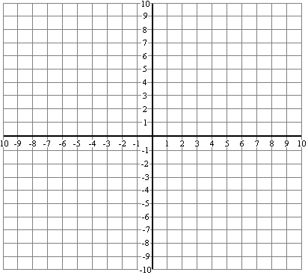

$x=$______ $y=$______ $x=$______ $y=$______

Directions: Solve the following systems of equations by substitution or combination (your choice!).
$y+\text{10}=6x$ $4y=2x+\text{20}$ $2y+6=\text{10}x$ $8+y=5x$
$2y+8=8x$ $y+3x=−9$ $y−2=5x$ $3y=3x−\text{12}$

$x=$______ $y=$______ $x=$______ $y=$______ $x=$______ $y=$______ $x=$______ $y=$______

Jack and Jill go on a date to Taco Bell (how romantic!). Jill eats 2 tacos and 3 enchiladas for $7.80 and Jack eats 3 tacos and 5 enchiladas for $12.70.

Step 1 – Name your variables: ______ = _________________________ ______ = _________________________
(letter) (description) (letter) (description)

Step 2 – Setup two equations: ________________________________ ________________________________

Step 3 – Solve the system of equations: _____ = _______________ _____ = _______________

______________________________________________________________________________________________

You and your friends are renting waverunners! Ocean City Rentals charges a rental fee of $30 plus an additional $1 per minute for a rental. Long Beach Inc. charges a $20 rental fee plus an additional $2 per minute.

Step 1 – Name your variables: ______ = _________________________ ______ = _________________________
(letter) (description) (letter) (description)

Step 2 – Setup two equations: ________________________________ ________________________________

Step 3 – Solve the system of equations: _____ = _______________ _____ = _______________

